UTC Swindon
Quality of Education:
Faculty | Science (Physics) A-Level

Statement of CURRICULUM INTENT

Our AS and A-level science qualifications build on the concepts and skills developed at GCSE, and focus on inspiring and relevant content that paves the way for the scientists of tomorrow. The specifications chosen aims to help inspire students, nurture their passion for the subject and lay the foundations for further study and the workplace. The specification allows the development of a bespoke context and helps bring chemistry to life in the way that best suits the needs of our students. The specifications have been written with minimal context. This allows staff to select the context and applications that they feel bring the subject alive. The AQA specification also supplies a range of excellent teaching resources that can be use alongside those developed by staff.

The content of the AS is identical and co-teachable to that of the first year of A-level, which allows flexibility in planning, timetabling and resourcing. The straightforward layout clearly lists what students need to know and highlights opportunities for skills development. The AS exams are similar in style to the A-level exams, testing a subset of the same content, with less difficulty. This allows our students to develop and helps us and our students decide if A-level is the right choice for them.

The AQA Specification at A-level was chosen to make sure that there is a seamless progression between qualifications.

Practical work is at the heart of all good science teaching, and the required practical activities will give students the opportunity to embed their skills and knowledge. The A-level practicals ensure that students are able to access the Common Practical Assessment Criteria (CPAC) requirements of the course.

Science is a set of ideas about the material world whether it be investigating, observing, experimenting or testing ideas and then thinking about them. The content allows scientific ideas to flow through the curriculum allowing students to build a deep understanding. This will involve students verbally communicating, reading and writing about science plus the actual doing as well as representing science in its many forms both mathematically and visually through modelling key scientific ideas.

The science curriculum encourages the development of knowledge and understanding in science through opportunities for working scientifically (the summation of all the activities that scientists do) and this is woven through the courses that the students study (CPAC).

Science is delivered using the TEEP model and aims to make science relevant by demonstrating its purpose and application in industry and the real world.

The core of the science curriculum deals with science in our everyday lives. We aim for our students to see science all around them; from the nutrients in the food they had at breakfast being digested, to understanding the large-scale implications of climate change science. The curriculum also aims to develop students who are equipped with the scientific knowledge required to understand the uses and implications of science, today and for the future, by engaging them in practical activities throughout the academic year. The science curriculum is not just focused on exams but using science to understand the world around us, cross-linking topics across disciplines, seeing its applicability in our own lives and the future we have ahead of us.

Statement of CURRICULUM IMPLEMENTATION (how are you going to ensure you meet your intent?)

The Physics specifications is a stepping stone to future study, and allows students to develop the skills that universities require. The course has been designed to inspire students, nurture a passion for
Physics and lay the groundwork for further study in science or engineering. A synopsis of the course content is detailed below.

3.1 Measurements and their errors
Content in this section is a continuing study for a student of physics. A working knowledge of the specified fundamental (base) units of measurement is vital. Likewise, practical work in the subject needs to be underpinned by an awareness of the nature of measurement errors and of their numerical treatment. The ability to carry through reasonable estimations is a skill that is required throughout the course and beyond.
3.2 Particles and radiation
This section introduces students both to the fundamental properties of matter, and to electromagnetic radiation and quantum phenomena. Teachers may wish to begin with this topic to provide a new interest and knowledge dimension beyond GCSE. Through a study of these topics, students become aware of the way ideas develop and evolve in physics. They will appreciate the importance of international collaboration in the development of new experiments and theories in this area of fundamental research.
3.3 Waves
GCSE studies of wave phenomena are extended through a development of knowledge of the characteristics, properties, and applications of travelling waves and stationary waves. Topics treated include refraction, diffraction, superposition and interference.
3.4 Mechanics and materials Vectors and their treatment are introduced followed by development of the student’s knowledge and understanding of forces, energy and momentum. The section continues with a study of materials considered in terms of their bulk properties and tensile strength. As with earlier topics, this section and also the following section Electricity would provide a good starting point for students who prefer to begin by consolidating work.
3.5 Electricity This section builds on and develops earlier study of these phenomena from GCSE. It provides opportunities for the development of practical skills at an early stage in the course and lays the groundwork for later study of the many electrical applications that are important to society.
3.6 Further mechanics and thermal physics (A-level only) The earlier study of mechanics is further advanced through a consideration of circular motion and simple harmonic motion (the harmonic oscillator). A further section allows the thermal properties of materials, the properties and nature of ideal gases, and the molecular kinetic theory to be studied in depth.
3.7 Fields and their consequences (A-level only) The concept of field is one of the great unifying ideas in physics. The ideas of gravitation, electrostatics and magnetic field theory are developed within the topic to emphasise this unification. Many ideas from mechanics and electricity from earlier in the course support this and are further developed. Practical applications considered include: planetary and satellite orbits, capacitance and capacitors, their charge and discharge through resistors, and electromagnetic induction. These topics have considerable impact on modern society.
3.8 Nuclear physics (A-level only) This section builds on the work of Particles and radiation to link the properties of the nucleus to the production of nuclear power through the characteristics of the nucleus, the properties of unstable nuclei, and the link between energy and mass. Students should become aware of the physics that underpins nuclear energy production and also of the impact that it can have on society
3.9 Astrophysics (A-level only) Fundamental physical principles are applied to the study and interpretation of the Universe. Students gain deeper insight into the behaviour of objects at great distances from Earth and discover the ways in which information from these objects can be gathered. The underlying physical principles of the devices used are covered and some indication is given of the new information gained by the use of radio astronomy. The discovery of exoplanets is an example of the way in which new information is gained by astronomers.
3.10 Medical physics (A-level only) Students with an interest in biological and medical topics are offered the opportunity to study some of the applications of physical principles and techniques in medicine. The physics of the eye and ear as sensory organs is discussed. The important and developing field of medical imaging, with both non-ionising and ionising radiations is considered. Further uses of ionising radiation are developed in a section on radiation therapy.
3.11 Engineering physics (A-level only) This option offers opportunities for students to reinforce and extend the work of core units by considering applications in areas of engineering and technology. It extends the student’s understanding in areas of rotational dynamics and thermodynamics. The emphasis in this option is on an understanding of the concepts and the application of physics. Questions can be set in novel or unfamiliar contexts, but in such cases the scene is set and any relevant required information is given.
3.12 Turning points in physics (A-level only) This option is intended to enable key concepts and developments in physics to be studied in greater depth than in the core content. Students will be able to appreciate, from historical and conceptual viewpoints, the significance of major paradigm shifts for the subject in the perspectives of experimentation and understanding. Many present-day technological industries are the consequence of these key developments and the topics in the option illustrate how unforeseen technologies can develop from new discoveries.
3.13 Electronics (A-level only) This option is designed for those who wish to learn more about modern electronic technologies as a development of their core work in electricity. A variety of discrete devices is introduced followed by discussions of both analogue and digital techniques ranging from the operational amplifier to digital signal processing. The option ends with a look at the issues surrounding data communication.

In addition, students will also be required to develop practical skills. Practical assessments have been divided into those that can be assessed in written exams and those that can only be directly assessed whilst students are carrying out experiments.

A-level grades will be based only on marks from written exams. Students will be required to complete a separate endorsement of practical skills throughout the 2 year course. This will be assessed by teaching staff and will be based on direct observation of students’ competency in a range of skills that are not assessable in written exams.

Use of Apparatus and Techniques

All students taking an A-level Physics qualification are expected to experience the use of a range of apparatus and develop and demonstrate a range of skills and practical techniques. These apparatus and techniques are common to all A-level Physics specifications.

There are three interconnected, but separate reasons for doing practical work at UTC Swindon. They are:

- To support and consolidate scientific concepts (knowledge and understanding). This is done by applying and developing what is known and understood of abstract ideas and models. Through practical work we are able to make sense of new information and observations, and provide insights into the development of scientific thinking.

- To develop investigative skills. These transferable skills include:
- Devising and investigating testable questions
- Identifying and controlling variables
- Analysing, interpreting and evaluating data.

- To build and master practical skills such as:
- Using specialist equipment to take measurements
- Handling and manipulating equipment with confidence and fluency
- Recognising hazards and planning how to minimise risk.

By focusing on the reasons for carrying out a particular practical, teachers will help students understand the subject better, to develop the skills of a scientist and to master the manipulative skills required for further study or jobs in STEM subjects.

Questions in the written exams will draw on the knowledge and understanding students have gained by carrying out the practical activities listed below. Teachers are encouraged to further develop students’ abilities by providing other opportunities for practical work throughout the course.

Practical work is seen as progresional and the skills and techniques learned will develop over time.

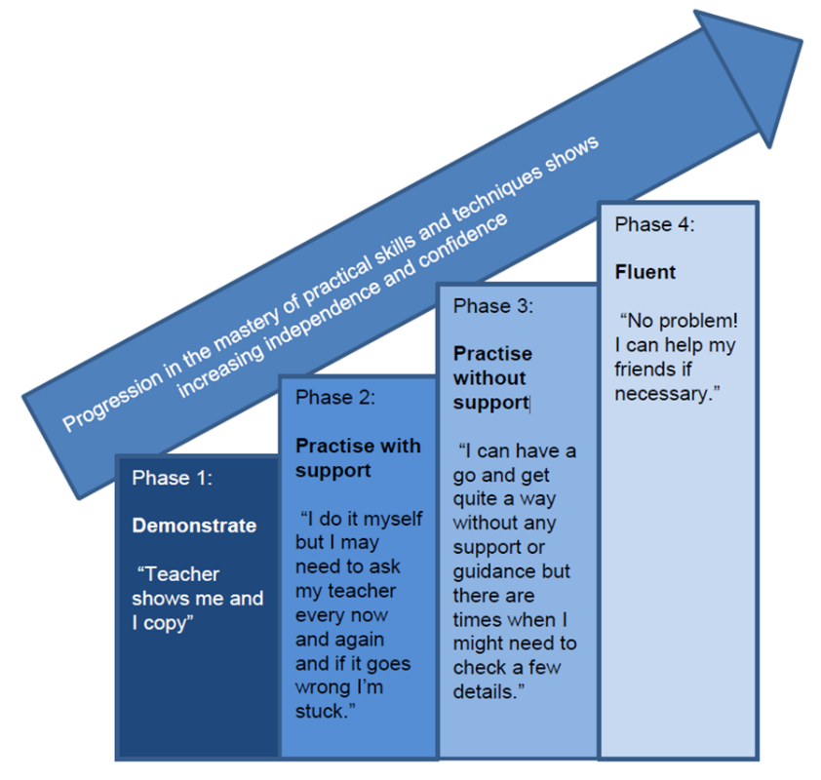

Required Activities

The following practical’s must be carried out by all students taking this course. Written papers will assess knowledge and understanding of these, and the skills exemplified within each practical.

These are the 12 required practical’s students are expected to complete over the two year course

 | Required Activity | Apparatus & Technique Reference
 | Investigation into the variation of the frequency of stationary waves on a string with length, tension and mass per unit length of the string. | a, b, c, i
 | Investigation of interference effects to include the Young’s slit experiment and interference by a diffraction grating. | a, j
 | Determination of g by a free-fall method. | a, c, d, k
 | Determination of the Young modulus by a simple method. | a, c, e
 | Determination of resistivity of a wire using a micrometer, ammeter and voltmeter. | a, b, e, f
 | Investigation of the emf and internal resistance of electric cells and batteries by measuring the variation of the terminal pd of the cell with current in it. | b, f, g
 | Investigation into simple harmonic motion using a mass-spring system and a simple pendulum. | a, b, c, h, i
 | Investigation of Boyle’s (constant temperature) law and Charles’s (constant pressure) law for a gas. | a
 | Investigation of the charge and discharge of capacitors. Analysis techniques should include log-linear plotting leading to a determination of the time constant RC. | b, f, g, h, k
 | Investigate how the force on a wire varies with flux density, current and length of wire using a top pan balance. | a, b, f
 | Investigate, using a search coil and oscilloscope, the effect on magnetic flux linkage of varying the angle between a search coil and magnetic field direction. | a, b, f, h
 | Investigation of the inverse-square law for gamma radiation. | a, b, k, i

Apparatus & Techniques

All students taking an A-level Chemistry qualification are expected to use the following apparatus and develop and demonstrate these techniques. These apparatus and techniques are common to all A-level Chemistry specifications.

Carrying out the 12 required practicals (detailed below) means that students will have experienced use of each of these apparatus and techniques. However, teaching staff are encouraged to develop students’ abilities by inclusion of other opportunities for skills development.

The students will develop and show competence of use for the following pieces of apparatus and required techniques

 | Apparatus & Techniques
AT a | Use appropriate analogue apparatus to record a range of measurements (to include length/distance, temperature, pressure, force, angles, volume) and to interpolate between scale markings
AT b | use appropriate digital instruments, including electrical multimeters, to obtain a range of measurements (to include time, current, voltage, resistance, mass)
AT c | use methods to increase accuracy of measurements, such as timing over multiple oscillations, or use of fiducial marker, set square or plumb line
AT d | use stopwatch or light gates for timing
AT e | use callipers and micrometres for small distances, using digital or vernier scales
AT f | correctly construct circuits from circuit diagrams using DC power supplies, cells, and a range of circuit components, including those where polarity is important
AT g | design, construct and check circuits using DC power supplies, cells, and a range of circuit components
AT h | use signal generator and oscilloscope, including volts/division and time-base
AT i | generate and measure waves, using microphone and loudspeaker, or ripple tank, or vibration transducer, or microwave / radio wave source
AT j | use laser or light source to investigate characteristics of light, including interference and diffraction
AT k | use ICT such as computer modelling, or data logger with a variety of sensors to collect data, or use of software to process data
AT l | use ionising radiation, including detectors

Practical Mastery

In order to achieve a pass, students will be required to have met the following expectations. Students are authorised to work in small groups but must be able to demonstrate and record evidence independently in order to demonstrate their personal competency. This must include evidence of independent application of investigative approaches and methods towards practical work. To be awarded a pass, students are required to consistently and routinely exhibit the following competences before completing the A-level course.

1. Follows written procedures | a. Correctly follows written instructions to carry out experimental techniques or procedures.
2. Applies investigative approaches and methods when using instruments and equipment | a. Correctly uses appropriate instrumentation, apparatus and materials (including ICT) to carry out investigative activities, experimental techniques and procedures with minimal assistance or prompting.  b. Carries out techniques or procedures methodically, in sequence and in combination, identifying practical issues and making adjustments when necessary.  c. Identifies and controls significant quantitative variables where applicable, and plans approaches to take account of variables that cannot readily be controlled.  d. Selects appropriate equipment and measurement strategies in order to ensure suitably accurate results.
3. Safely uses a range of practical equipment and materials | a. Identifies hazards and assesses risks associated with these hazards, making safety adjustments as necessary, when carrying out experimental techniques and procedures in the lab or field.  b. Uses appropriate safety equipment and approaches to minimise risks with minimal prompting.
4. Makes and records observations | a. Makes accurate observations relevant to the experimental or investigative procedure.  b. Obtains accurate, precise and sufficient data for experimental and investigative procedures and records this methodically using appropriate units and conventions.
5. Researches, references and reports | a. Uses appropriate software and/or tools to process data, carry out research and report findings.  b. Cites sources of information demonstrating that research has taken place, supporting planning and conclusions.

Practical skills to be assessed in written papers

Overall, at least 15% of the marks for all A-level Physics courses will require the assessment of practical skills.
In order to be able to answer these questions, students need to have been taught, and to have acquired competence in, the appropriate areas of practical skills as indicated in the tables of coverage below.

Independent thinking
Practical Skill Reference | Key Skill
PS 1.1 | Solve problems set in practical contexts
PS 1.2 | Apply scientific knowledge to practical contexts

Use and application of scientific methods and practices
Practical Skill Reference | Key Skill
PS 2.1 | Comment on experimental design and evaluate scientific methods
PS 2.2 | Present data in appropriate ways
PS 2.3 | Evaluate results and draw conclusions with reference to measurement uncertainties and errors
PS 2.4 | Identify variables including those that must be controlled

Numeracy and the application of mathematical concepts in a practical context
Practical Skill Reference | Key Skill
PS 3.1 | Plot and interpret graphs
PS 3.2 | Process and analyse data using appropriate mathematical skills as exemplified in the mathematical appendix for each science
PS 3.3 | Consider margins of error, accuracy and precision of data

Instruments and equipment
Practical Skill Reference | Key Skill
PS 4.1 | Know and understand how to use a wide range of experimental and practical instruments, equipment and techniques appropriate to the knowledge and understanding included in the specification

A-level practical skills to be assessed via endorsement

The assessment of practical skills is a compulsory requirement of the course of study for A-level qualifications in biology, chemistry and physics. It will appear on all students’ certificates as a separately reported result, alongside the overall grade for the qualification. The arrangements for the assessment of practical skills will be common to all awarding organisations. These arrangements will include:

- A minimum of 12 practical activities to be carried out by each student which, together, meet the requirements of Appendices 5b (Practical skills identified for direct assessment and developed through teaching and learning) and 5c (Use of apparatus and techniques) from the prescribed subject content, published by the Department for Education. The required practical activities will be defined by each awarding organisation.
- Teachers will assess students against Common Practical Assessment Criteria (CPAC) issued jointly by the awarding organisations. The CPAC are based on the requirements of Appendices 5b and 5c of the subject content requirements published by the Department for Education, and define the minimum standard required for the achievement of a pass.
- Each student will keep an appropriate record of their practical work, including their assessed practical activities.
- Students who demonstrate the required standard across all the requirements of the CPAC will receive a ‘pass’ grade.
- There will be no separate assessment of practical skills for AS qualifications.
- Students will answer questions in the AS and A-level exam papers that assess the requirements of Appendix 5a (practical skills identified for indirect assessment and developed through teaching and learning) from the prescribed subject content, published by the Department for Education. These questions may draw on, or range beyond, the practical activities included in the specification.

- Arithmetic and numerical computation

 | Mathematical Skill | Exemplification of mathematical skill in the context of Chemistry
MS 0.1 | Recognise and make use of appropriate units in calculations | Students may be tested on their ability to:  - identify the correct units for physical properties such as m s ⁻¹ , the unit for velocity  - convert between units with different prefixes eg cm³ to m³
MS 0.2 | Recognise and use expressions in decimal and standard form | Students may be tested on their ability to:  - use physical constants expressed in standard form such as c = 3.00 x 108 m s ⁻¹
MS 0.3 | Use ratios, fractions and percentages | Students may be tested on their ability to:  - calculate efficiency of devices  - calculate percentage uncertainties in measurements
MS 0.4 | Estimate results | Students may be tested on their ability to:  - estimate the effect of changing experimental parameters on measurable values
MS 0.5 | Use calculators to find and use power, exponential and logarithmic functions | Students may be tested on their ability to:  - solve for unknowns in decay problems such as N = N₀e^{− λt}
MS 0.6 | Use calculators to handle sin x, cos x, tan x when x is expressed in degrees or radians | Students may be tested on their ability to:  - calculate the direction of resultant vectors

- Handling data

 | Mathematical Skill | Exemplification of mathematical skill in the context of Chemistry
MS 1.1 | Use an appropriate number of significant figures | Students may be tested on their ability to:  - Report calculations to an appropriate number of significant figures, given raw data quoted to varying numbers of significant figures  - Understand that calculated results can only be reported to the limits of the least accurate measurement
MS 1.2 | Find arithmetic means | Students may be tested on their ability to:  - calculate a mean value for repeated experimental readings
MS 1.3 | Understand simple probability | Students may be tested on their ability to:  - understand probability in the context of radioactive decay
MS 1.4 | Make order of magnitude calculations | Students may be tested on their ability to:  - evaluate equations with variables expressed in different orders of magnitude
MS 1.5 | Identify uncertainties in measurements and use simple techniques to determine uncertainty when data are combined by addition, subtraction, multiplication, division and raising to powers | Students may be tested on their ability to:  - determine the uncertainty where two readings for length need to be added together

- Algebra

 | Mathematical Skill | Exemplification of mathematical skill in the context of Chemistry
MS 2.1 | Understand and use the symbols: =, <, <<, >>, >, ∝, Δ, ≈ | Students may be tested on their ability to:  - recognise the significance of the symbols in the expression:$F∝$ ∆p/∆t
MS 2.2 | Change the subject of an equation | Students may be tested on their ability to:  - rearrange E = mc² to make m the subject
MS 2.3 | Substitute numerical values into algebraic equations using appropriate units for physical quantities | Students may be tested on their ability to:  - calculate the momentum p of an object by substituting the values for mass m and velocity v into the equation p = mv
MS 2.4 | Solve algebraic equations | Students may be tested on their ability to:  - solve kinematic equations for constant acceleration such as v = u + at and s = ut + ½ at²
MS 2.5 | Use logarithms in relation to quantities that range over several orders of magnitude | Students may be tested on their ability to:  - recognise and interpret real world examples of logarithmic scales

- Graphs

 | Mathematical Skill | Exemplification of mathematical skill in the context of Chemistry
MS 3.1 | Translate information between graphical, numerical and algebraic forms | Students may be tested on their ability to:  - calculate Young modulus for materials using stress–strain graphs
MS 3.2 | Plot two variables from experimental or other data | Students may be tested on their ability to:  - plot graphs of extension of a wire against force applied
MS 3.3 | Understand that y = mx + c represents a linear relationship | Students may be tested on their ability to:  - rearrange and compare v = u + at with y = mx + c for velocity–time graph in constant acceleration problems
MS 3.4 | Determine the slope and intercept of a linear graph | Students may be tested on their ability to:  - read off and interpret intercept point from a graph eg the initial velocity in a velocity–time graph
MS 3.5 | Calculate rate of change from a graph showing a linear relationship | Students may be tested on their ability to:  - calculate acceleration from a linear velocity–time graph
MS 3.6 | Draw and use the slope of a tangent to a curve as a measure of rate of change | Students may be tested on their ability to:  - draw a tangent to the curve of a displacement– time graph and use the gradient to approximate the velocity at a specific time
MS 3.7 | Distinguish between instantaneous rate of change and average rate of change | Students may be tested on their ability to:  - understand that the gradient of the tangent of a displacement–time graph gives the velocity at a point in time which is a different measure to the average velocity
MS 3.8 | Understand the possible physical significance of the area between a curve and the x axis and be able to calculate it or estimate it by graphical methods as appropriate | Students may be tested on their ability to:  - recognise that for a capacitor the area under a voltage–charge graph is equivalent to the energy stored
MS 3.9 | Apply the concepts underlying calculus (but without requiring the explicit use of derivatives or integrals) by solving equations involving rates of change, eg Δx/Δt = − λx using a graphical method or spreadsheet modelling | Students may be tested on their ability to:  - determine g from distance-time plot for projectile motion
MS 3.10 | Interpret logarithmic plots | Students may be tested on their ability to:  - obtain time constant for capacitor discharge by interpreting plot of log V against time
MS 3.11 | Use logarithmic plots to test exponential and power law variations | Students may be tested on their ability to:  - use logarithmic plots with decay law of radioactivity / charging and discharging of a capacitor
MS 3.12 | Sketch relationships which are modelled by:  - y = k/x,  - y = kx²  - y = k/x²  - y = kx  - y = sin x,  - y = cos x  - y = e^{±x}  - and y = sin² x, y = cos² x as applied to physical relationships | Students may be tested on their ability to:  - sketch relationships between pressure and volume for an ideal gas

- Geometry and Trigonometry

 | Mathematical Skill | Exemplification of mathematical skill in the context of Chemistry
MS 4.1 | Use angles and shapes in regular 2D and 3D structures | Students may be tested on their ability to:  - interpret force diagrams to solve problems
MS 4.2 | Visualise and represent 2D and 3D forms including two-dimensional representations of 3D objects | Students may be tested on their ability to:  - draw force diagrams to solve mechanics problems
MS 4.3 | Calculate areas of triangles, circumferences and areas of circles, surface areas and volumes of rectangular blocks, cylinders and spheres | Students may be tested on their ability to:  - calculate the area of the cross–section to work out the resistance of a conductor given its length and resistivity
 | Use Pythagoras’ theorem, and the angle sum of a triangle | Students may be tested on their ability to:  - calculate the magnitude of a resultant vector, resolving forces into components to solve problems
 | Use sin, cos and tan in physical problems | Students may be tested on their ability to:  - resolve forces into components
 | Use of small angle approximations including:  - sinθ ≈ θ  - tan θ ≈ θ  - cos θ ≈ 1  for small θ where appropriate | Students may be tested on their ability to:  - calculate fringe separations in interference patterns
 | Understand the relationship between degrees and radians and translate from one to the other | Students may be tested on their ability to:  - convert angle in degrees to angle in radians

Assessment. Students are entered for the FULL A-Level and not the AS-Level
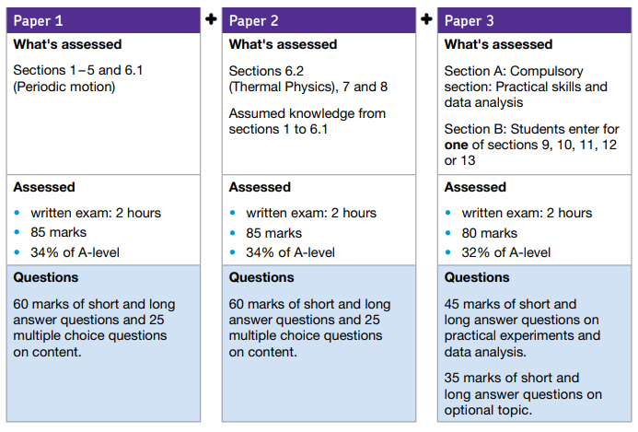

Practical skills to be assessed in written papers
Overall, at least 15% of the marks for all A-level Physics courses will require the assessment of practical skills. In order to be able to answer these questions, students need to have been taught, and to have acquired competence in, the appropriate areas of practical skills as indicated in the table of coverage below.

